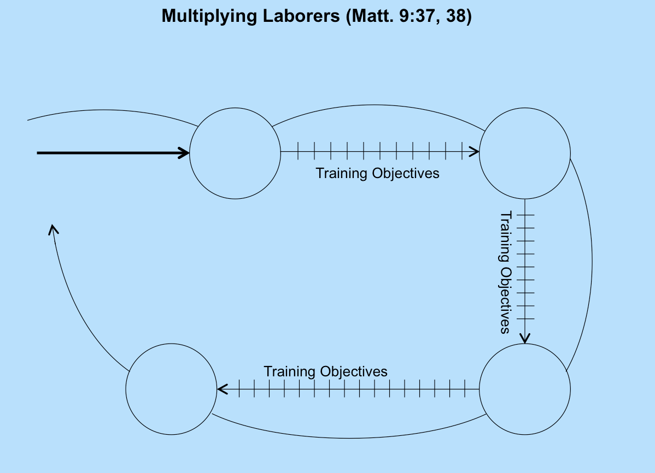

6

5

8

The Process:

18

16

17

13

19

9

7

15

14

The Process:

10

11

12

“The Result”

The Process:

4

3

2

1

“The Result”

“The Result”

“The Result”

The Process: